**5. Smallest Subarray with Sum greater than N**

This problem has been solved with the more efficient way that we could think of.

.

* Only one function has been created that solves the given problem
* **Smallsubarray()** takes in 3 arguments: the input array, it’s size and the number N
* we took two pointers p1 and p2 for the array starting with zero, and tried to move p1 first until we found a subarray from p2 to p1, to find the smallest of such subarray whose sum is greater than 1, we then move p2 alongside, and keep updating the value of minimum length **minlen** of subarray, along with updating **minarrstart** which helps us indicate the starting point of the smallest subarray,
* Later, we print the subarray from starting point as minarrstart to the length minlen and add minlen to each value while printing to get the desired output.

**Execution Screenshots:  
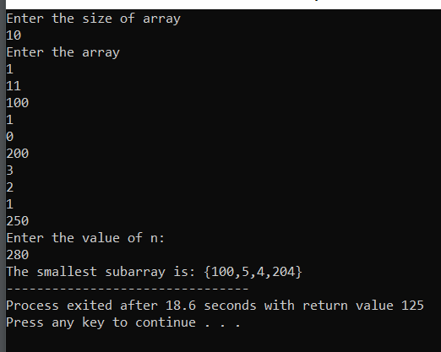**

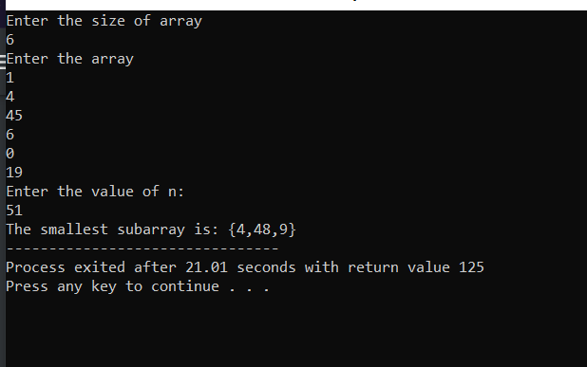

**Debug Screenshot:  
